Requesting a new PC
- Select the Helpdesk tile on the staff portal
or go to https://hwu.topdesk.net/tas/public/ssp/
- Log in with your usual HWU username and password
- The Helpdesk Home page will open
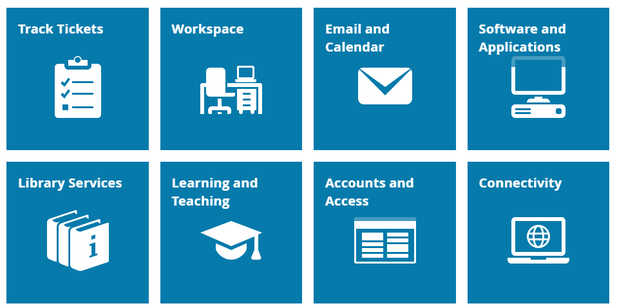

- Select the Workspace tile
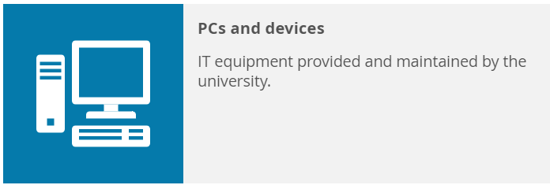
- Then select the PCs and devices tile

- There are three options for requesting a new PC, laptop, monitor, keyboard etc.
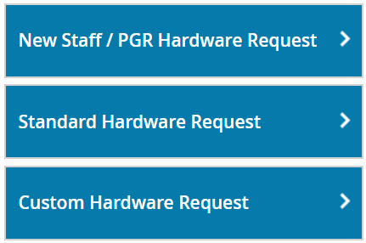
- Within each option, there are details of the items that are available.
- Once you have decided on your preferred option then ‘Add to cart’

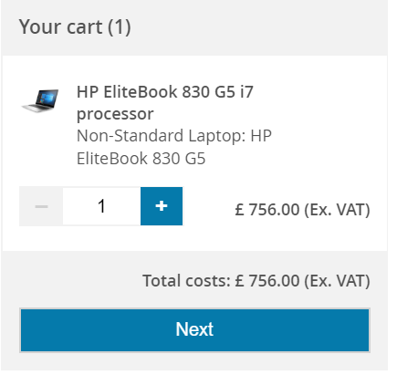
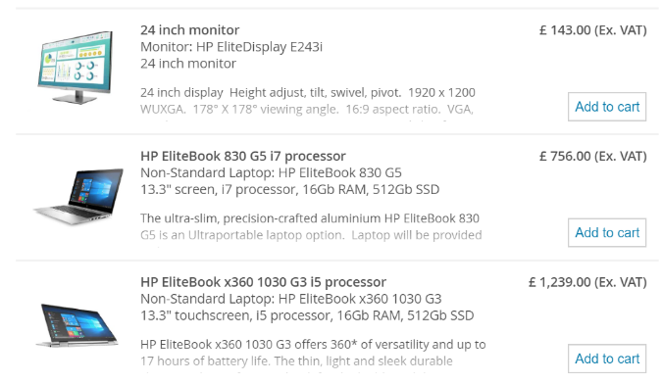

- Before you can confirm your order, you will need to fill in the details in the form including the cost code. This means that we can capture the information that we need to process the order.
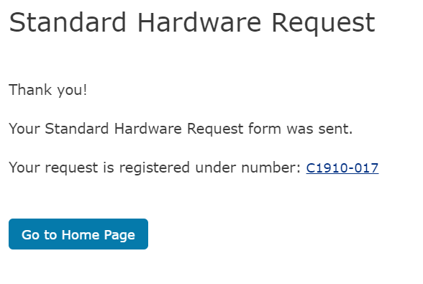
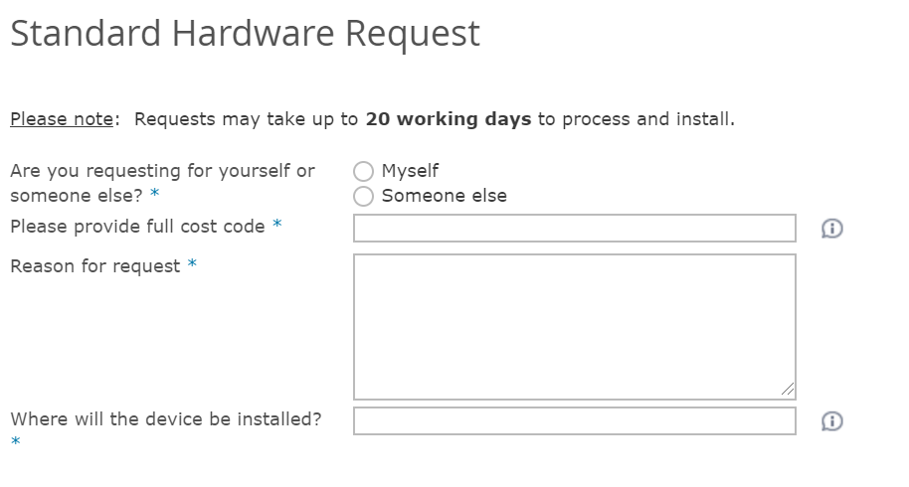
- Depending on which option you have chosen, an expected time for processing including installing, will be displayed. You will receive a confirmation that your request has been received.
- To check on the progress of your order and any other requests, faults or enquiries you have submitted, select the Track Tickets tile from the Home Page

- If you require any help or support, please email ISHelp@hw.ac.uk or phone 4045

